**ECSE 543 Assignment 2 Report**

**Q1**

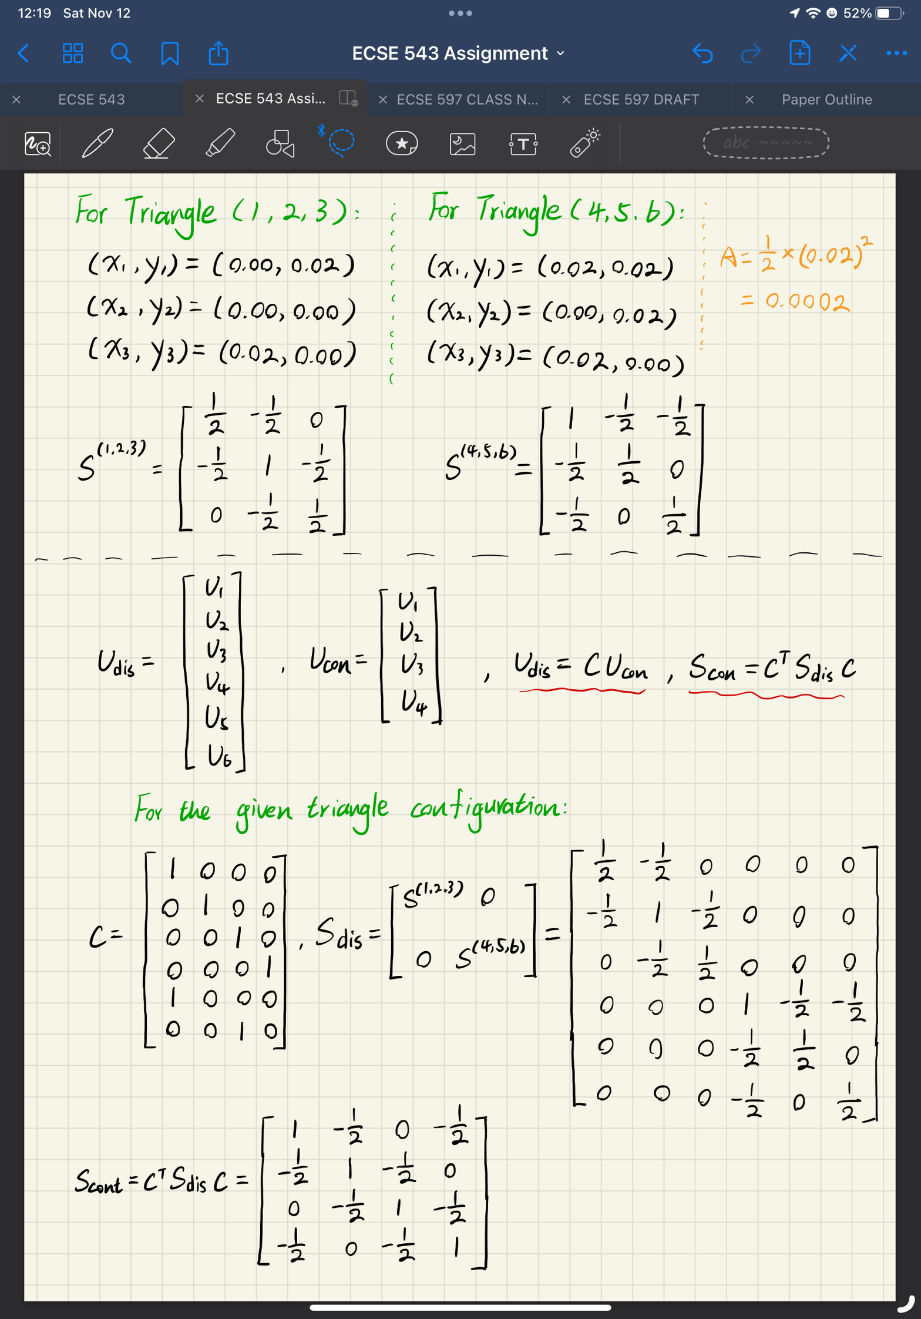

**Q2**

a)

The two-element mesh configuration of the lower-left quarter of the co-axial cable is shown below in Figure 1. The nodes, including the boundary nodes, are labelled with numbers. The blue boundary has the potential of 0 volt, the red boundary has the potential of 110 volts, and the green boundaries are boundaries of symmetry. There are in total of 34 nodes and 46 triangles. Thus, the input data file has 34 entries for the node locations, and 46 entries for the triangle mesh configurations, as shown in Figure 2 and 3. Figure 4 shows the boundary conditions, where the nodes on the blue boundary (in Figure 1) are set to 0 volts, and the nodes on red boundaries (in Figure 1) are set to 110 volts.

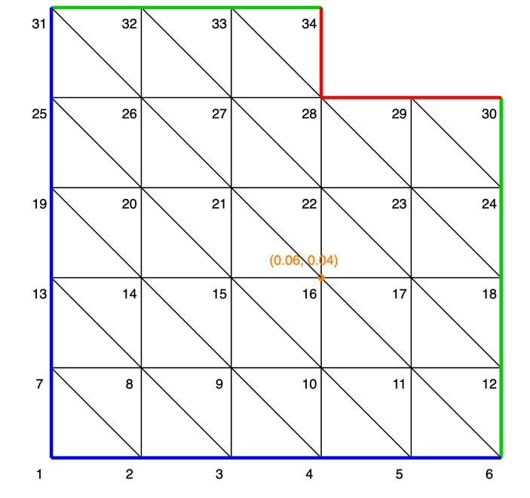

Figure - Q1 Mesh Configuration

Figure - Q2 Node Numbering Figure - Q2 Triangle Mesh Figure – Q2 Boundary Conditions

b)

The output of the **SIMPLE2D** program is shown in Figure 5. The potential at the location of **(x,y) = (0.06, 0.04)** equals to **40.5365 volts**.

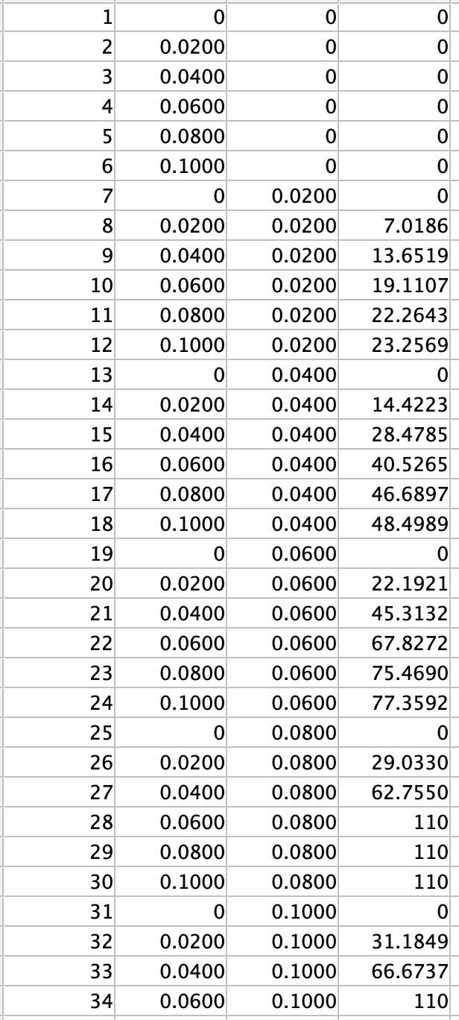

Figure - Q2 Potential Results

c)

The total energy per unit length of the capacitor () can be calculated with the following equations:

The capacitance per unit length () can then be calculated with the following equation:

The values of and have already been calculated in the provided MATLAB code. The MATLAB code modification to extract these values is attached in the Appendix. The energy per unit length of the capacitor can then be calculated with Equation (1). However, since the and is only for one-quarter of the capacitor, the actual energy to be used in Equation (2) needs to be **four times** the calculated one with Equation (1). The voltage difference is given, which equals to 110 volts. The capacitance per unit length () is calculated to be 52.136 pF/m, as shown in Figure 6. The program for capacitance per unit length calculation is attached in the Appendix.



Figure - Q2 Capacitance Result

**Q3**

a)

The Conjugate Gradient method is implemented, which is attached in the Appendix. The equation to be solved for Q3 has the form of . The node numbering for Q3 is shown in Figure 7, and the corresponding matrix is shown in Figure 8. The idea for the matrix generation is similar to the Q3 in Assignment 1, where the potential at one node is related to the nearby nodes. The nodes on the blue and red boundaries, as shown in Figure 7, are not numbered, since these boundary conditions are not included in the matrix but are used to form the right-hand-side (RHS) vector of the matrix equation, as shown in Figure 9. The values are negative as they are on the RHS of the equation. The formed matrix shown in Figure 7 is clearly not symmetric positive definite (SPD), which is also confirmed with Cholesky Decomposition, as shown in Figure 10. To modify the equation, one rule can be utilized, where **for any n-by-n, non-singular matrix , is SPD**. The formed matrix is non-singular, where all rows of are different, so that would be SPD. Therefore, the matrix equation can be modified to , and would still be the original solution to the problem. The matrix modification code is shown in Figure 11.

Figure - Q3 Node Numbering

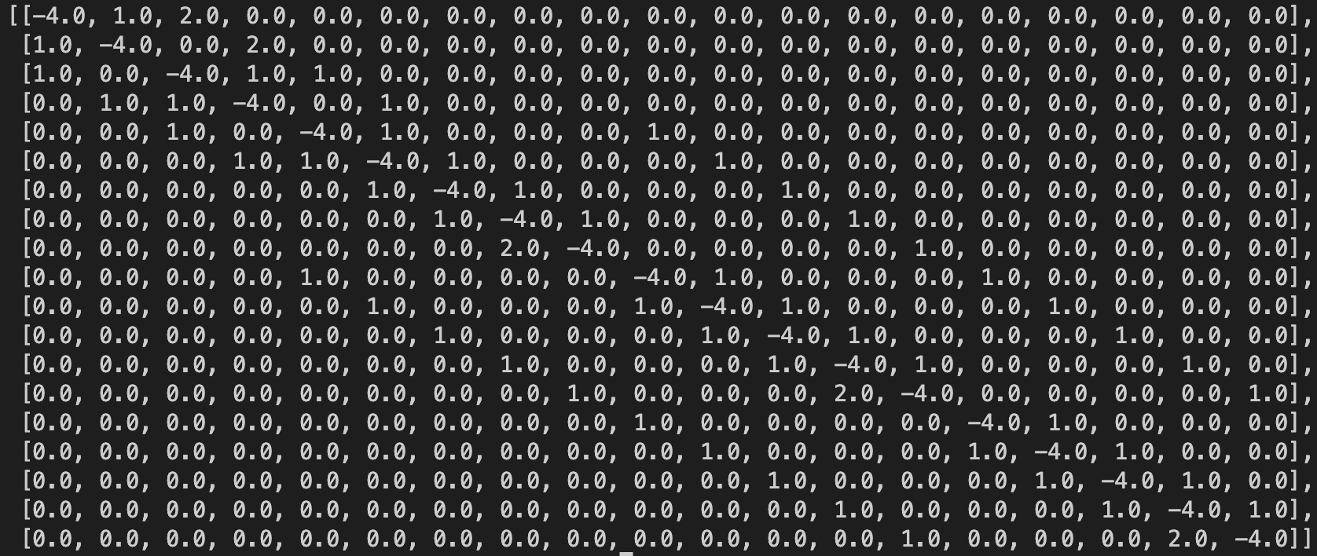

Figure - Q3 Matrix



Figure - Q3 RHS Vector



Figure - Q3 Cholesky Failed for Non-SPD Matrix



Figure - Matrix Modification for SPD

b)

The solutions to the matrix equations using Cholesky Decomposition and Conjugate Gradient are shown in Figure 12, where the sequence of the potential at each node follows the node numbering in Figure 7.

Figure - Cholesky Decomposition & Conjugate Gradient Results

c)

The infinity norm and the 2-norm of the residual vector versus the number of iterations for the conjugate gradient program is shown in Figure 13. The norms of the residual vector gradually decrease, indicating that the solution gradually converges as expected. The implementation of the infinity norm and the 2-norm are attached in the Appendix.

Figure - Infinity Norm & 2-Norm versus Number of Iterations

d)

Table 1 shows the potentials at (x, y) = (0.06, 0.04), calculated with SOR (h=0.02) in Assignment 1, Finite Element in Q2, Cholesky Decomposition in Q3 and Conjugate Gradient in Q3. The potential results at (0.06, 0.04) for all the methods are **extremely close** to each other.

|  |  |  |  |  |
| --- | --- | --- | --- | --- |
| Method  Location | A1 – SOR (volts) | A2Q2 (volts) | A2Q3 – Cholesky (volts) | A2Q3 – CG (volts) |
| (0.06, 0.04) | 40.526502245388045 | 40.526502611225640 | 40.52650261122577 | 40.52650261123335 |

Table - Potential at (0.06, 0.04) with Different Methods

e)

As the potential at each node is calculated with CG method, the same strategy for capacitance per unit length calculation can be used as the **part c)** of Q2. The can be formed with the calculated potentials and the boundary conditions, and the matrix needs to be adjusted according to the node numbering as shown in Figure 7.

**Appendix**

**MATLAB File Modification**

(Extra output **Sglob** is added for the capacitance calculation)

**Capacitance Calculation**

**Conjugate Gradient Program**

**Infinity Norm & 2-Norm**

**Calculated Potentials for all Nodes**

|  |  |  |  |
| --- | --- | --- | --- |
| Method  Location | A2Q2 | A2Q3 - Cholesky | A2Q3 - CG |
| (0.02, 0.02) | 7.018554351943976 | 7.018554351944022 | 7.018554351962819 |
| (0.02, 0.04) | 14.422288394164253 | 14.42228839416434 | 14.422288394120862 |
| (0.02, 0.06) | 22.192121868154793 | 22.1921218681549 | 22.192121868225577 |
| (0.02, 0.08) | 29.033009671223510 | 29.033009671223596 | 29.033009671125196 |
| (0.02, 0.1) | 31.184935941368620 | 31.184935941368693 | 31.184935941438166 |
| (0.04, 0.02) | 13.651929013611650 | 13.651929013611722 | 13.651929013597345 |
| (0.04, 0.04) | 28.478477356558248 | 28.478477356558376 | 28.478477356598926 |
| (0.04, 0.06) | 45.313189407231420 | 45.31318940723157 | 45.313189407158546 |
| (0.04, 0.08) | 62.754980875370606 | 62.754980875370705 | 62.7549808754696 |
| (0.04, 0.1) | 66.673724423027450 | 66.67372442302754 | 66.67372442295772 |
| (0.06, 0.02) | 19.110684345944392 | 19.110684345944467 | 19.11068434593021 |
| (0.06, 0.04) | 40.526502611225640 | 40.52650261122577 | 40.52650261123335 |
| (0.06, 0.06) | 67.827177528842010 | 67.82717752884213 | 67.82717752885274 |
| (0.08, 0.02) | 22.264305758940290 | 22.264305758940345 | 22.26430575898954 |
| (0.08, 0.04) | 46.689671213557915 | 46.68967121355802 | 46.68967121349636 |
| (0.08, 0.06) | 75.469018096911030 | 75.46901809691111 | 75.46901809694691 |
| (0.1, 0.02) | 23.256867476258822 | 23.25686747625887 | 23.256867476217728 |
| (0.1, 0.04) | 48.498858387154710 | 48.498858387154804 | 48.49885838720863 |
| (0.1, 0.06) | 77.359223645244190 | 77.35922364524426 | 77.35922364520964 |